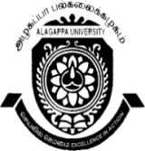
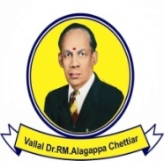
ALAGAPPA UNIVERSITY, KARAIKUDI –630003
(Reaccredited with “A” Grade by NAAC)
DIRECTORATE OF DISTANCE EDUCATION
(Recognized by Distance Education Council, New Delhi)

Website:www.alagappauniversity.ac.in Email:dde@alagappauniversity.ac.in
Phone:04565-223400 Fax:04565-225216
Ref: D9/DDE/PCP/2016 Date: 15.02.2016
Prof. P. SIVAKUMAR
DIRECTORi/c

Sub: DDE - Conduct of P.C.P classes - reg.

*******

The Personal Contact Programme (PCP) of the following courses for the AY 2015-2016 will be held as per the following schedule:-

Courses: B.A (English), B. A (History), B. A (P.A), B. Sc. (Psychology), B. Sc. (Mathematics),
B. Sc. (CS), for Tamil Language only.

Venue | Course | Date | Time
Directorate of Distance Education,  Alagappa University,  Karaikudi. | All B.A & B. Sc  (I Year) | 21.03.2016 | 10.00 A.M  To  05.00 P.M

The Candidates are instructed to check their Name, Enrolment Number and Address given in the envelope with the Identity Card and discrepancies if any, should be reported to the undersigned immediately.

You are also advised to bring your I.D. Card at the time of attending PCP. It is very useful for the candidates to attend PCP all the days to sit for University examinations.

DIRECTOR

To
Student concerned

